1. Exploratory Analysis.

1.a Race Distribution

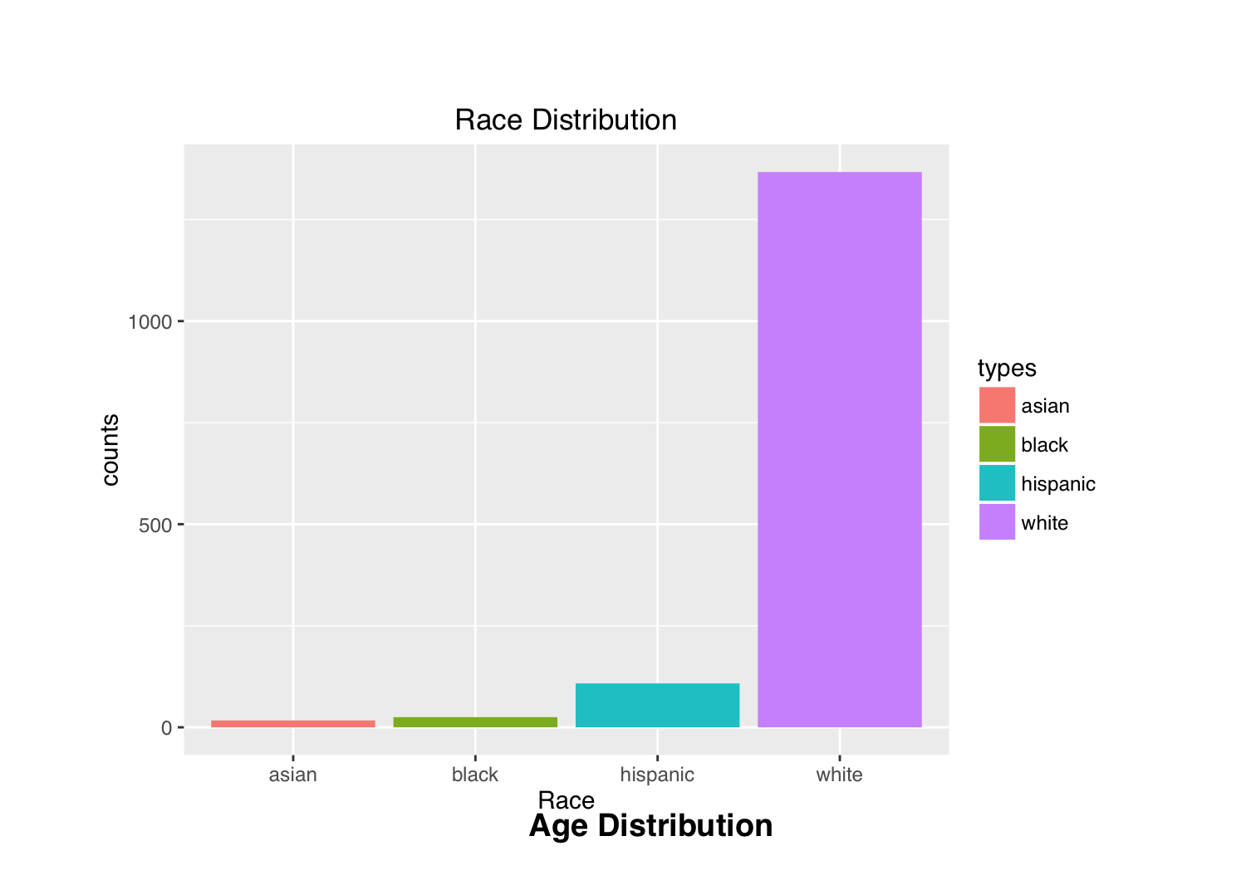

1.a Age Distribution before defining limits between 35 and 90

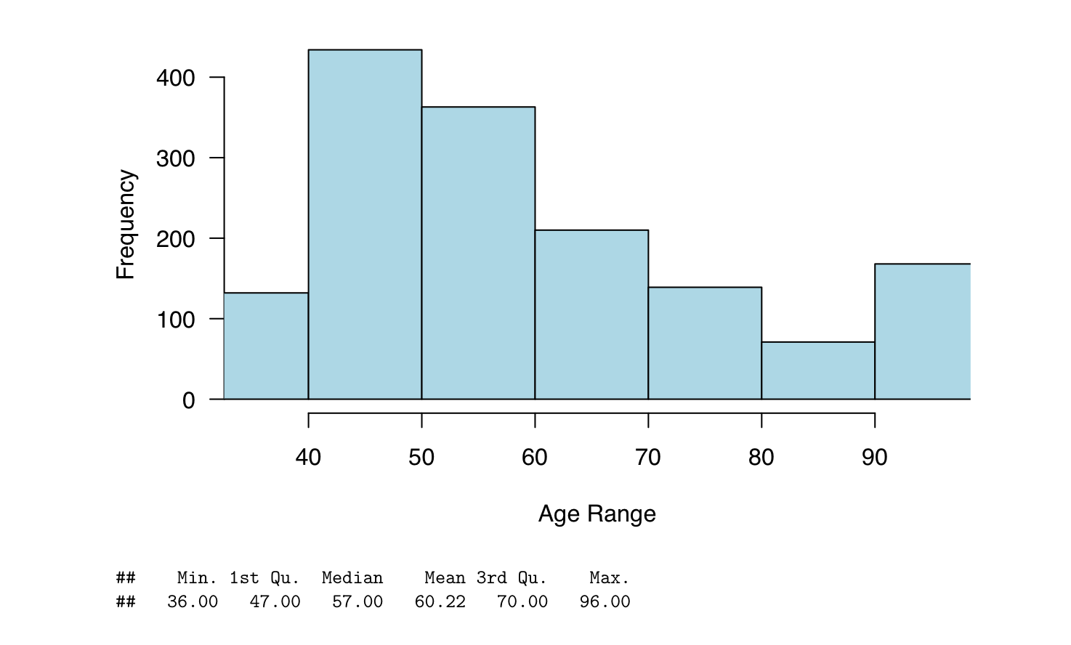

2. Distribution of lifetime and 5 years projection absolute risk for all combination of age and race

Using combination of race and ages in one model to derive their absolute risks, below is the distribution of those absolute risks

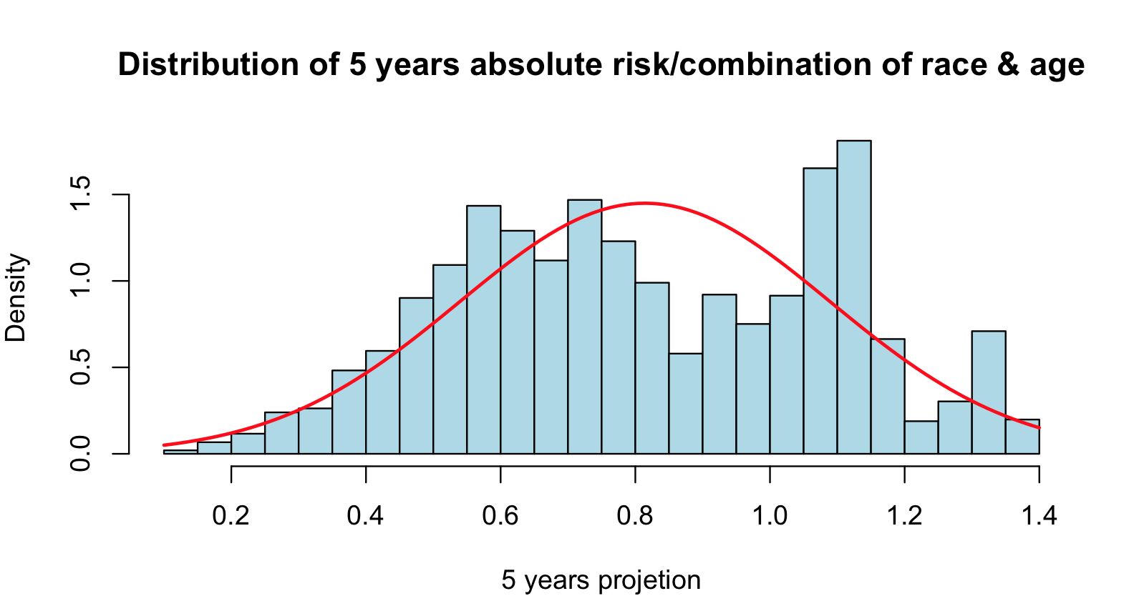

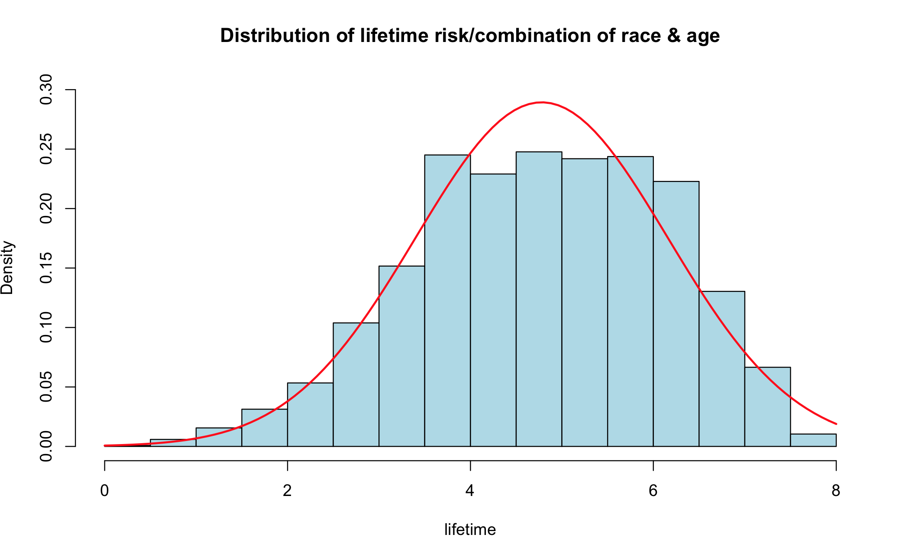

2. Distributions of absolute risk 5 year projection and lifetime with variability in age

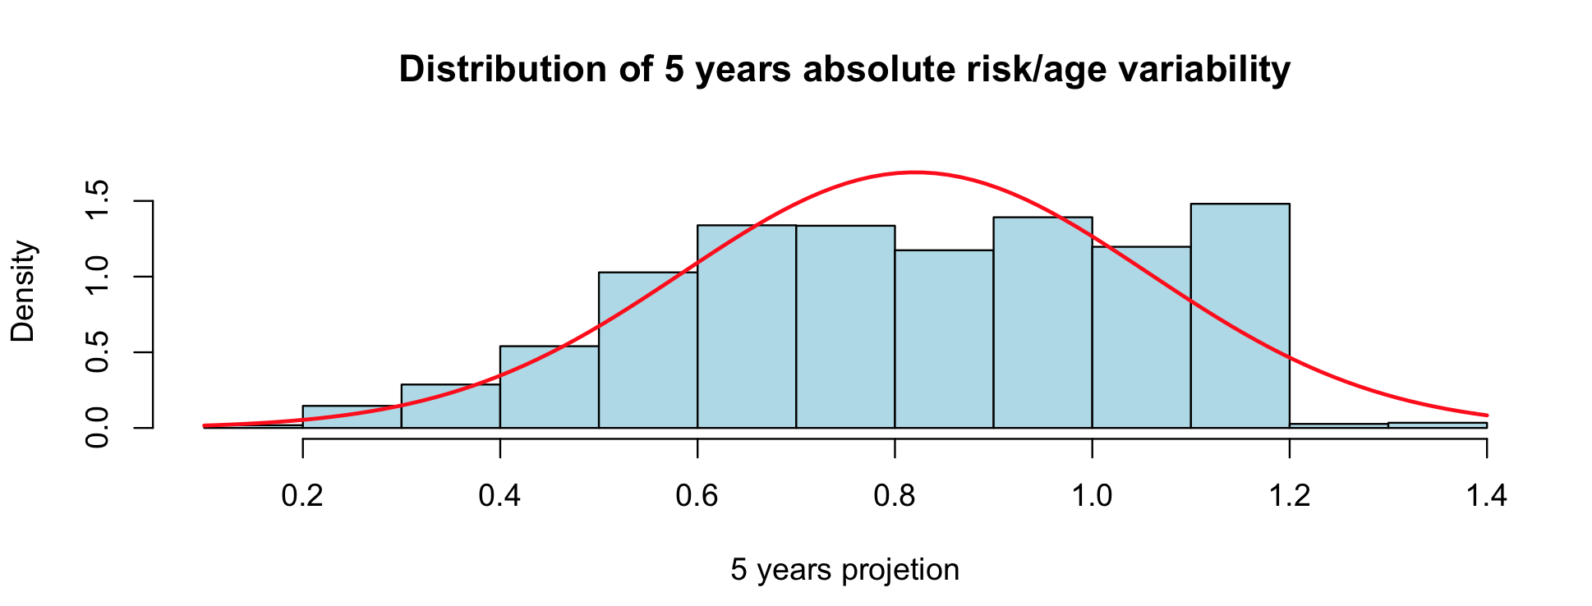

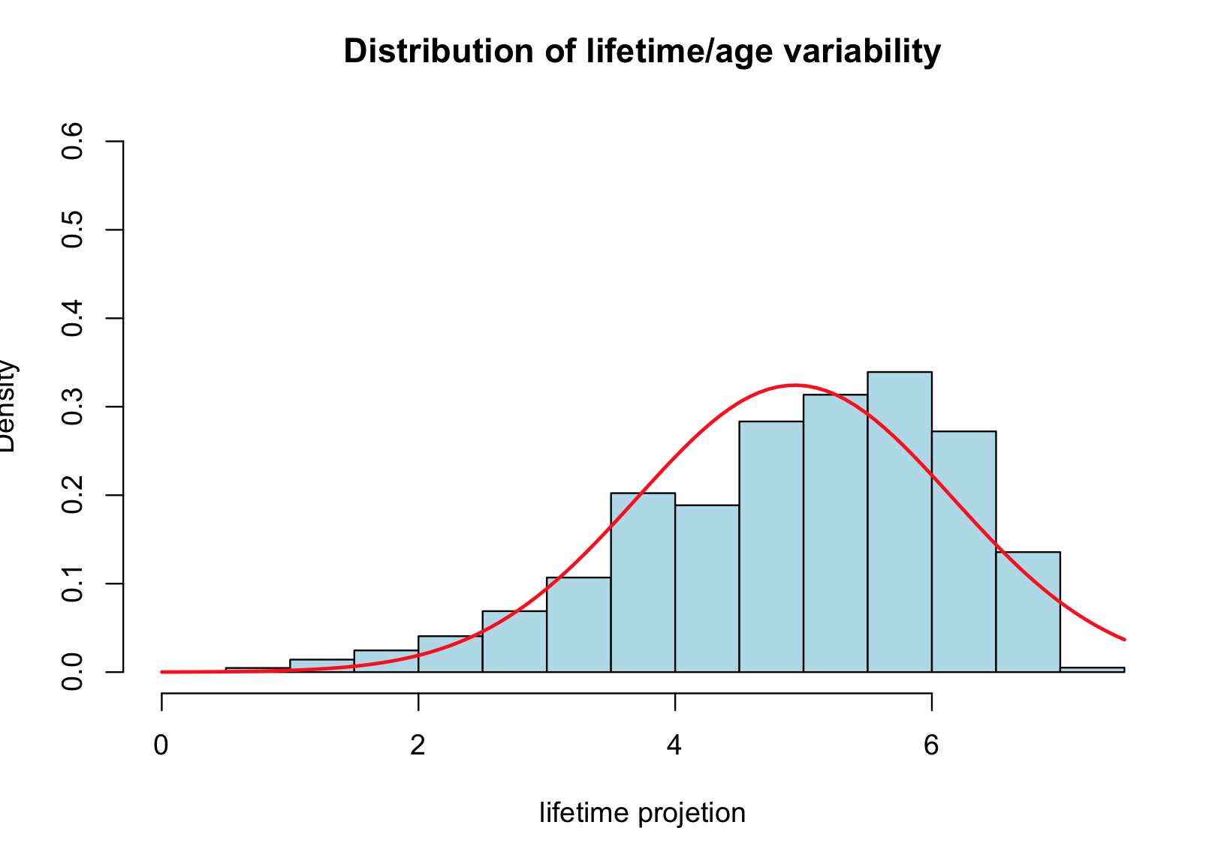

3. Distributions of absolute risk 5 year projection and lifetime using median age

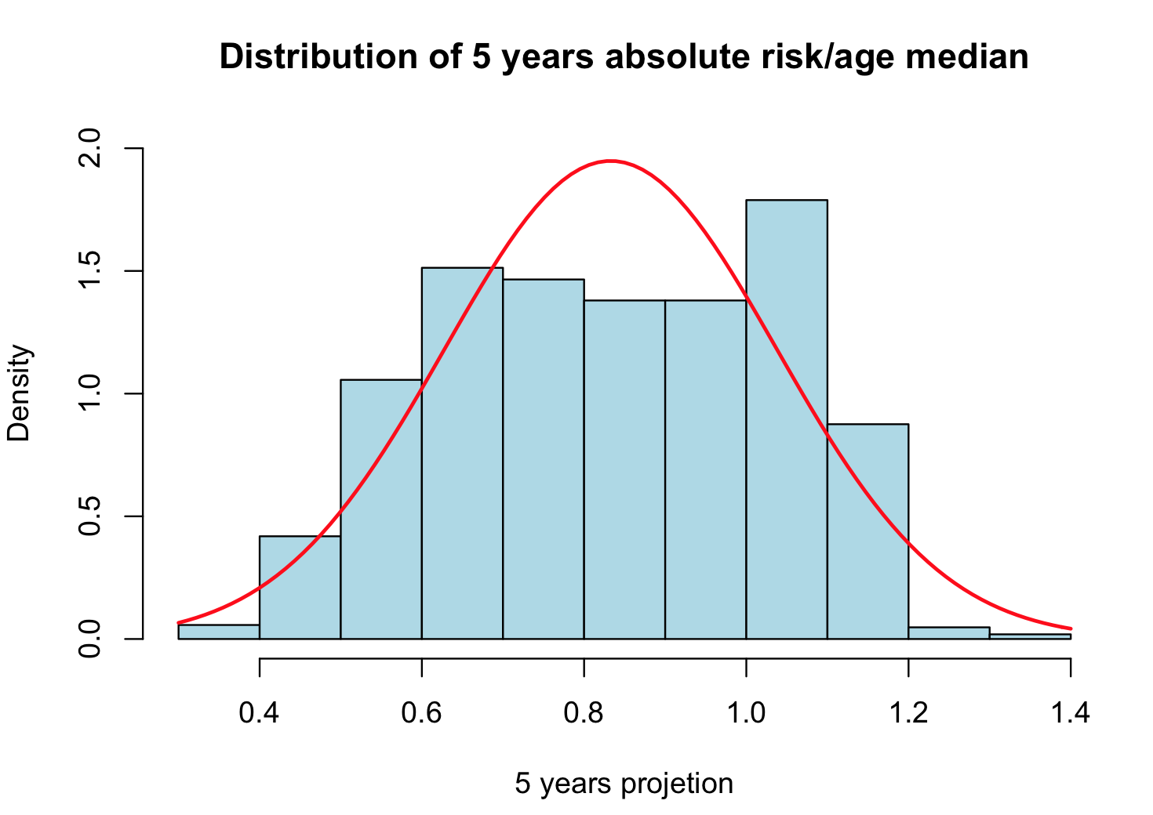

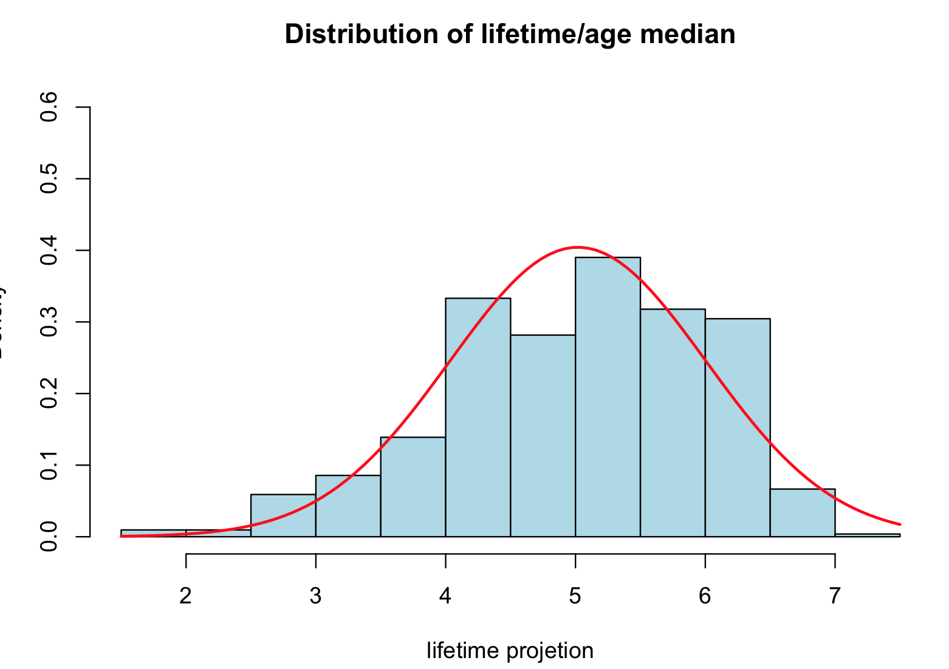

4. Distributions of absolute risk 5 year projection and lifetime with race variability

